**Visualizations**

**Consumer Complaints distribution among US States**

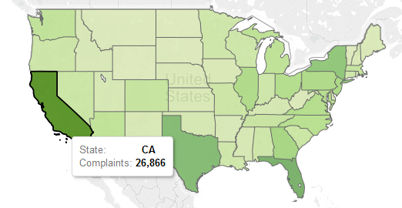

**Products with Most Complaints**

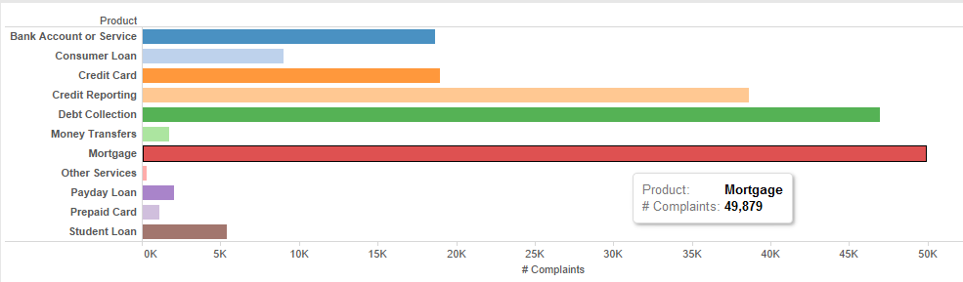

**Top Five Companies with Most Complaints**

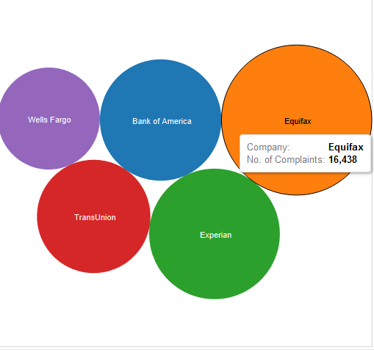

**Most common Issues in complaints**

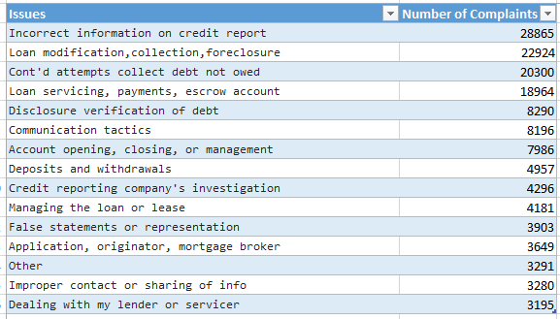

**Mode of Complaints**

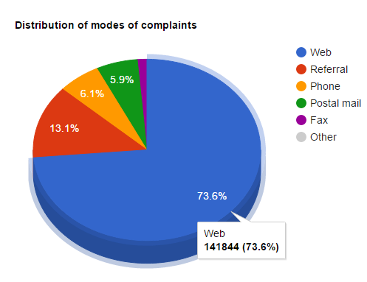

**Trend in number of complaints over the last year**

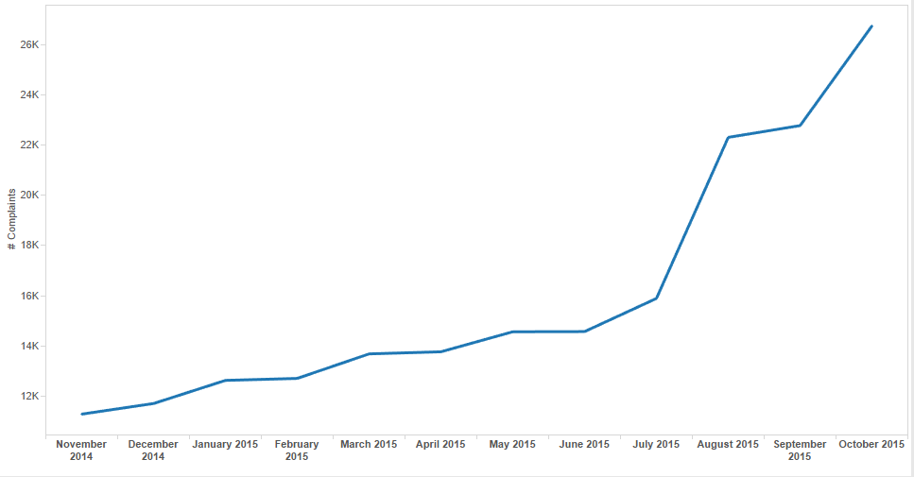

**Companies that closed consumer complaints timely**

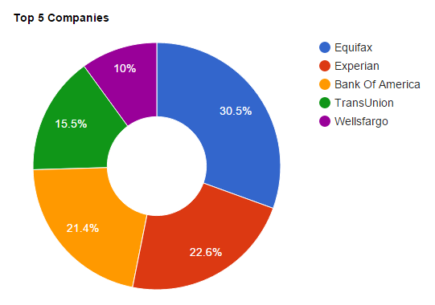

**Top Companies that chose to close the complaints with monetary relief**

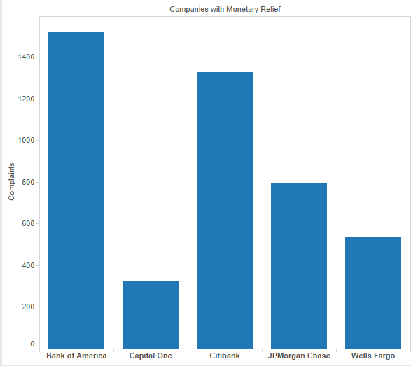

**Comparison of product specific complaints for 2014 and 2015**

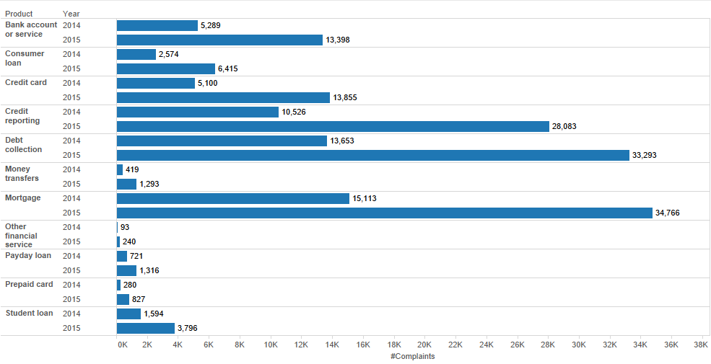

**Most Common Response provided by Companies**

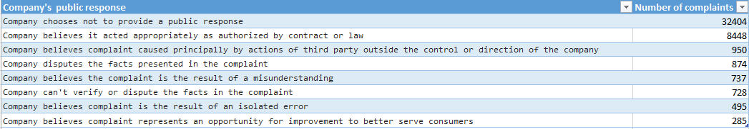

**Issues with most complaints for different products**

**All Products**

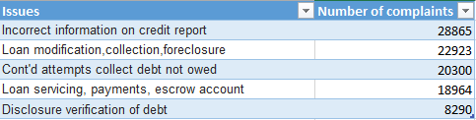

**Mortgage**

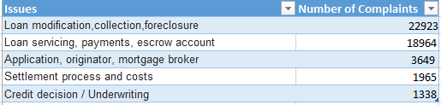

**Debt Collection**

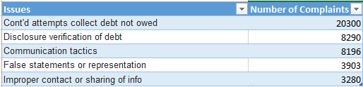

**Credit Reporting**

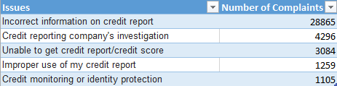**Companies with most complaints by product**

